The Decatur Way…is the way to GROW!
Pride * Achievement * Respect * Responsibility

GEOMETRY
Miss Stokes
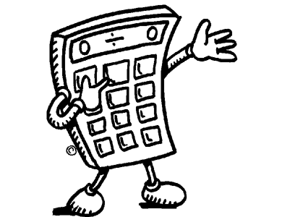
Fall 2011
Stephen Decatur High School

Office: Room D-164
Email: SMStokes@mail.worcester.k12.md.us
Schedule:
Course Room
Period 1: Geometry D-140
Period 2: Planning D-164 (Mathematics Office)
Period 4: Geometry B-1020 (Black Box Theater)
Period 5: Geometry A-269 (A-169)

Text Book: Discovering Geometry: An Investigative Approach
- Author: Serra, Michael
- Publisher: Key Curriculum Press 2003

Course Description: Geometry includes the study of properties of shapes consistent with the Maryland Core Learning Goal 2. Inductive reasoning, deductive reasoning, and constructions are incorporated in the discovery of angle relationships and properties of specific polygons and circles. Additional topics include points, lines, planes, parallelism, transformations, coordinate geometry, congruence, right triangles, and similarities, areas of plane figures, surface areas, and volumes of solid figures. This course is recommended for college bound students.

Expectations:
- All school rules will be followed as outlined in Student Handbook.
- Students are expected to be in class on time and prepared (homework, binder, pencil, agenda…). No one is allowed to leave the room without an agenda!
- Students are responsible to keep an organized three ring binder which will include the following sections: Warm-ups, Notes, Homework, and Quizzes/Tests.
- If a student is absent, it is that student’s responsibility to retrieve any missed notes and assignments. There is a bin labeled with your class period. Your missed work and assignments will be placed in the designated area with your name on them.
- No cell phones will be used during class. It will be confiscated if I see it. The same goes for I-pods, MP3 players, or any other electronic devices.
- Be respectful of your teacher and classmates. When the teacher is talking, you are listening. The same goes for a fellow classmate. If he or she is talking, you are quiet and respectful.

Materials:

- Three Ring Binder * Dividers
- Paper * Pencils
- Optional: A calculator will be beneficial to have for out of class assignments, but it is not mandatory to purchase one. There will be calculators provided in class each day.

*** Projects will be incorporated throughout the course. Each will be explained in detail as we approach each topic ***

Grading:

Homework 15%
Class Work 20%
Quizzes 20%
Tests 30%
Midterm Exam 5%
Final Exam * 10%

*All students enrolled in Geometry are required to take a county developed midcourse and final exam that reflect the NCTM standards. The midterm will be at the end of the first quarter and the final exam will be at the end of the second quarter.

Student Signature: _______________________________________ Date: ________________
Parent/Guardian (Printed Name): ___________________________
Parent/Guardian Signature: ________________________________ Date: ________________
Parent/Guardian Phone: ___________________________________

